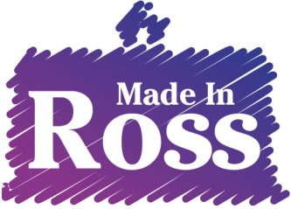
Information for Prospective Artists and Makers
What we are looking for
- High quality work to complement our existing members
We would like a wide range of arts and crafts and particularly want new members who can add to the variety on display. Please have a look at the range of arts and crafts we have currently at the Market House or on our leaflet and website: www.courtyard.org.uk/madeinross or come and visit us
- Living in a 20 mile radius of Ross-on-Wye
You don't have to live in Herefordshire, just in or near Ross-on-Wye
- Subject to a preliminary interview
We will want to meet you, make sure you know what will be involved and offer you a chance to ask questions
Here is what you can expect if you join Made in Ross
- A unique place to display and sell your work
- Opportunities to run workshops and demonstrations to share your skills with local people
- A community of local artists and crafts people dedicated to the development of Ross-on-Wye as a thriving creative place
Sales of your work will be subject to a 20% Commission payable to The Courtyard
And in return you will
- Join the co-operative (£1 share + £120.00 annual subscription running from April to end of March or £90.00 if joining on or after January 1st to end of March)
- Take a fair share in stewarding the space
This will be for approximately 4-5 x half days month but you will need to be flexible depending on the number of members. Practical activities involved in stewarding will include handling money (operating the cash register, end of day sales etc.), operating the lift and lights, entering sales on a computer spreadsheet, be computer savvy enough to use gmail emailing and upload jpeg images of own work, cleaning the space we use.
- Attend members meetings (every three months)
- Abide by the rules and uphold the values of Made in Ross
- Please read the terms of reference attached carefully

